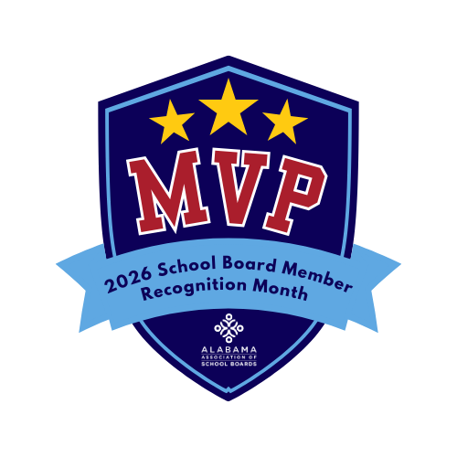

School Board Member Recognition Month
To be mailed by the superintendent or Chamber of Commerce

Sample Letter to Employers
To be mailed by the superintendent or chamber of commerce
Dear (Employer Name),
I am writing to sincerely thank you for your support of (Employee’s Name) and for allowing them the time and flexibility to serve on the (School System Name) Board of Education.
This January, we celebrate School Board Member Recognition Month under the theme School Board Members: The Real MVPs. The theme reflects the behind-the-scenes leadership, teamwork, and dedication required of school board members as they work to support student success and strengthen public education.
Serving on a school board requires significant time and thoughtful commitment. (Employee’s Name) brings leadership, insight and a strong sense of responsibility to this role, qualities that benefit not only our schools but our entire community. Their service would not be possible without the understanding and encouragement of employers like you.
Your willingness to support civic leadership demonstrates a shared commitment to the future of our community’s children. We are grateful for your partnership and for recognizing the importance of strong local leadership in public education.
Thank you again for supporting (Employee’s Name) as they serve as one of our school system’s real MVPs.
Sincerely,
(Name)
(Title)
(School System / Organization)

