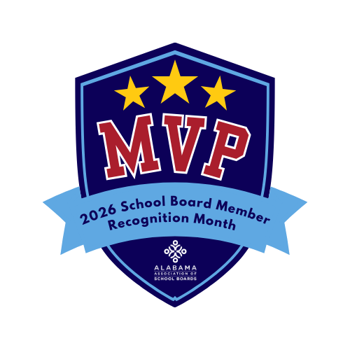
Suggestions For Celebrating Your School Board Members
- Feature board members for “MVP Highlights” on social media or the district website
- Collect handwritten notes or artwork from students and present them at a board meeting or compile into a booklet.
- Schools share short recognition messages during morning announcements throughout January.
- Add “School Board Members: The Real MVPs” to school marquees, homepage banners, or email signatures.
- Begin a January board meeting with a brief recognition, certificate presentation, or applause.
- Create simple “MVP cards” for each board member featuring their role, years of service, and a fun stat (e.g., “Meetings Attended”). (Download a pre-made template: here)
- Encourage students and staff to wear school or district “team colors” in honor of board members.
- Set up a Hall of Fame bulletin board or digital slideshow highlighting board members as “All-Star Leaders.”
- Ask principals and teachers to submit one sentence on how board leadership supports their work.
- Provide small snacks or “game day” treats at meetings with tags like “Thanks for Being Our MVP!”
- Share a fun graphic showing “Wins” such as graduation rates, new programs, or facility improvements.
- Have student-athletes or coaches record thank-you messages using sports-themed language

