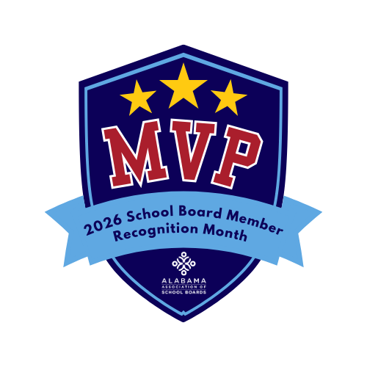
School Board Member
Recognition Month

For use by local city councils, county commissions,
student councils or parent-teacher organizations

WHEREAS, public education is vital to the strength, success, and future of our community; and

WHEREAS, local school board members serve as the governing body of public schools by establishing policies, setting direction, and ensuring accountability for student achievement; and

WHEREAS, school board members represent community voices, preserve local control of public education, and advocate for the needs of students, families, and educators; and

WHEREAS, school board members work collaboratively with superintendents and school leaders to ensure safe learning environments, effective instruction, and responsible stewardship of public resources; and

WHEREAS, school board members selflessly dedicate their time, knowledge, and leadership to serve students and strengthen public education;

NOW, THEREFORE, BE IT RESOLVED that (governing body name) does hereby recognize and salute the members of the (school system name) Board of Education and proclaims January 2026 as School Board Member Recognition Month, honoring them as School Board Members: The Real MVPs.

