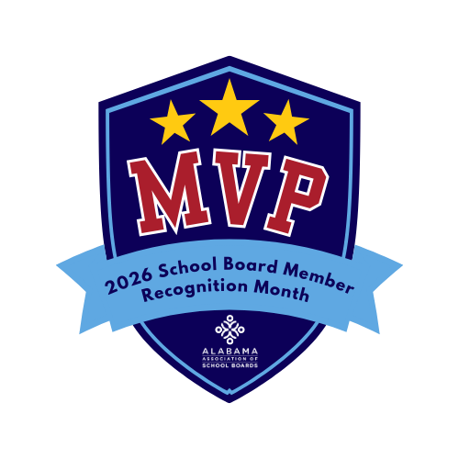
School Board Members: The Real MVPs
In sports, the Most Valuable Player is the one whose leadership, preparation, and decision-making elevate the entire team. In public education, that same description fits our local school board members.
This January, during School Board Member Recognition Month, we proudly recognize school board members as The Real MVPs, leaders whose work often happens behind the scenes, yet whose impact is felt every day in classrooms, hallways, and communities across Alabama.
School board members are entrusted with one of the community’s most important responsibilities: governing public schools in a way that supports student success while reflecting local values. They set the vision for the school system, adopt policies, oversee budgets, and ensure accountability for academic outcomes and fiscal stewardship. These decisions are complex, far-reaching, and often made under challenging circumstances.
Unlike professional athletes, school board members serve without the spotlight or applause. They balance board service with full-time jobs, family commitments, and community involvement. They attend lengthy meetings, review extensive materials, participate in training and engage with stakeholders all to ensure students have access to safe, strong and meaningful learning environments.
School board members also serve as a vital link between the community and the classroom. They listen to parents, educators, students, and taxpayers, weighing diverse perspectives while keeping the best interests of children at the center of every decision. Their leadership ensures that public education remains locally governed, transparent, and responsive to community needs.
Across Alabama, more than 130 local school boards work collaboratively with superintendents and educators to strengthen public education. Their efforts shape not only what students learn today, but how well prepared they are for tomorrow’s workforce, higher education, and civic life.
As we observe School Board Member Recognition Month, we encourage everyone to take a moment to recognize these dedicated public servants. A thank-you note, a social media post, or a kind word of appreciation can go a long way in acknowledging their service.
To the school board members of (school system name) and across our state: thank you for your leadership, your teamwork, and your unwavering commitment to students. You may not wear jerseys or step onto a playing field, but your impact is undeniable. You are, without question, The Real MVPs of public education.

