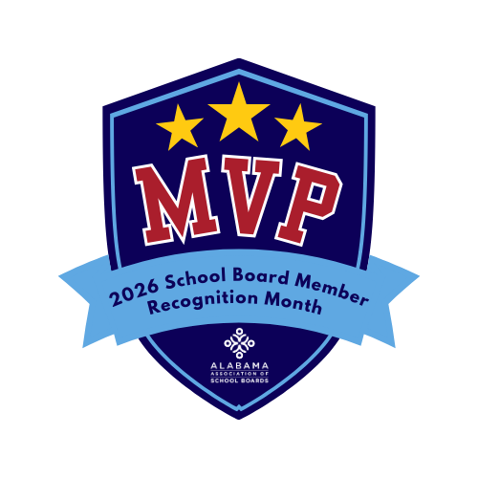

To be typed on school system letterhead and mailed to local media outlets.

FOR RELEASE JANUARY 2026 For more information contact:
(Person’s name) (Phone number)

JANUARY IS SCHOOL BOARD MEMBER RECOGNITION MONTH
(City, Alabama) — January is School Board Member Recognition Month, and (school system name) proudly recognizes its school board members as The Real MVPs of public education.
School board members play a critical role in shaping the success of students, schools, and communities. As elected or appointed leaders, they set the vision for the school system, establish policies, oversee budgets and ensure accountability, often while balancing full-time careers and family responsibilities.
“The decisions our board members make every day have a lasting impact on students and educators,” said (Superintendent’s Name). “They are strategic leaders, thoughtful listeners, and tireless advocates for children. Simply put, our school board members are the real MVPs of our school system.”
Under the board’s leadership, (school system name) has achieved notable accomplishments, including (insert district achievements, initiatives, awards, or improvements). These successes reflect the board’s commitment to student achievement, fiscal responsibility, and community engagement.
Members currently serving on the (school system name) Board of Education include:
- (Name) — (# years of service)
- (Name) — (# years of service)
- (Name) — (# years of service)
- (Name) — (# years of service)
- (Name) — (# years of service)
Throughout January, students, parents, staff, and community members are encouraged to join in recognizing board members by sharing messages of appreciation, writing thank-you notes, or highlighting their service on social media.
Learn more about the role of school boards and public education leadership at AlabamaSchoolBoards.org.

###

