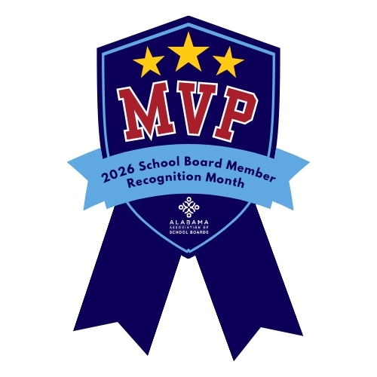

School Board Member Recognition Month

Schools, not to mention local businesses, can use their marquees to thank school board members for their service to the community during January. Here are a few suggest- ed messages to place on marquees, to post on bulletin boards, to display on electronic signs or to send out as tweets or via other social media:

Sample Social Media Posts

Short + Social-Friendly
- They may not wear jerseys, but they lead our schools to victory. 🏆 #SchoolBoardMVPs
- Every winning team has a strategy. Ours starts with strong school board leadership.
- To our school board: thanks for always keeping students in the starting lineup.
- The scoreboard says it all, our schools win because you lead. 🙌
- Champions of public education, on and off the field.
- Because of them, our students stay in the game and keep scoring big.
- To the Real MVPs: thank you for championing Alabama’s public schools.

Longer Storytelling Captions
- Strong schools need strong leadership! Our school board brings it every day. From tough decisions to big-picture planning, they’re the backbone of our community’s success. Help us celebrate School Board Recognition Month and thank the Real MVPs behind our schools! 🏆
- Behind every successful school is a team of dedicated leaders working behind the scenes. This month, we honor our school board members for their commitment to students, their service to our community, and their championship-level leadership.
- They don’t ask for applause, but they deserve a standing ovation. This month we recognize the school board members who show up, put in the work, and advocate for every child’s success. They’re truly the Real MVPs.

CATCH PHRASES & TAGLINES
- School Board Members: The Real MVPs.
- Champions for Students. Champions for Schools.
- Leadership That Keeps Us in the Win Column.
- Building a Game Plan for Success.
- Strong Boards. Strong Schools. Strong Team.
- Guiding Every Play for Student Success.
- In the Game for Alabama’s Students.
- Our Students’ Success Starts with Champions Like You.
- Making Big Plays for Public Education.
- The Heart of the Team, the Eyes on the Future.
- No Timeouts Needed, Just Dedicated Service.
- Victory Begins with Vision.

