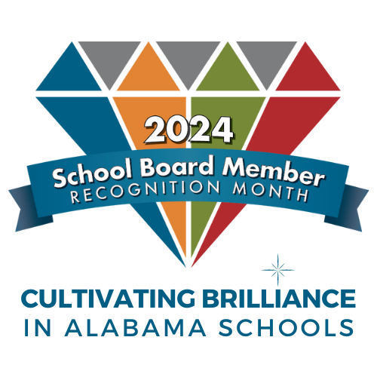
SCHOOL BOARD MEMBER RECOGNITION MONTH JANUARY 2024

CERTIFICATE
OF APPRECIATION
AWARDED TO

Board Member’s Name
For outstanding service and dedication to the
Board of Education

