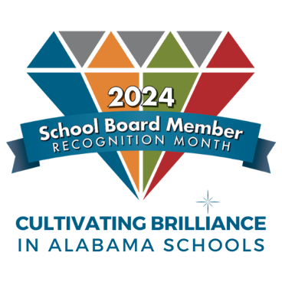
Sample Messages

School Board Member Recognition Month

Schools, not to mention local businesses, can use their marquees to thank school board members for their service to the community during January. Here are a few suggest- ed messages to place on marquees, to post on bulletin boards, to display on electronic signs or to send out as tweets or via other social media:

- We appreciate our school board for all the wonderful things they do!
#ThanksBOE #CultivatingBriliance

- Thank you, school board members, for helping cultivate brilliance in our schools!

- We join the nation in celebrating School Board Member Appreciation Month and recognize the invaluable contributions of our local board members in providing quality education to our children. #ThanksBOE

- Our school board members are dedicated to cultivating brilliance in our students. Thank you for your commitment to education!

- Shoutout to our amazing school board members for their tireless efforts to make our schools the best they can be. Your dedication to cultivating brilliance in our students is truly inspiring! #SchoolBoardMonth #ThanksBOE

- School Boards: Cultivating Brilliance in Alabama Schools!
- January is School Board Recognition Month. Thank you, School Board Members! #ThanksBOE #CultivatingBrilliance
- From supporting teachers to advocating for equitable access to resources, our school board members are champions for our students. Thank you for all that you do! #SchoolBoardMonth
- Our school boards provide extraordinary service toward helping children thrive and fulfill their potential. Thank you! #SchoolBoardMonth
- School boards make a powerful difference in our communities and for our children. #SchoolBoardMonth

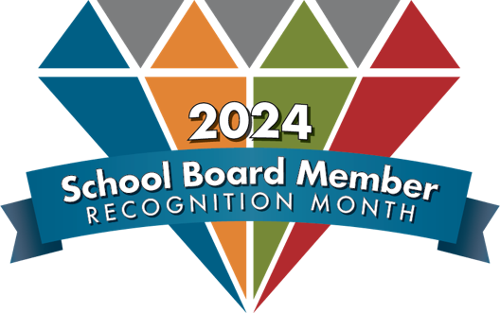
Sample Messages

Marquee Messages

- 2024 School Board Recognition Month
- Thank you, school board!
- School boards: Launching our next generation
- Thank a school board member today!
- Serving our kids and community
- We appreciate our school board members!
- _______ School Board working to make a difference!
- Elected to serve our students!

