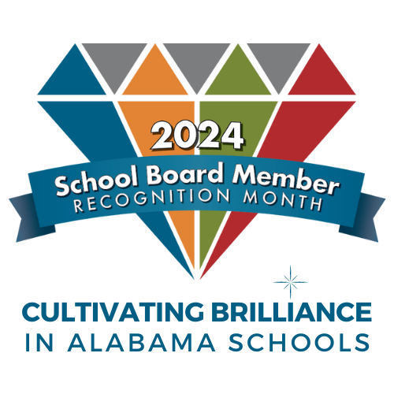
Sample Resolution

School Board Member Recognition Month

For use by local city councils, county commissions,
student councils or parent-teacher organizations

WHEREAS, recognizes the importance of public education in our community; and
WHEREAS, appreciates the vital role played by those individuals who, as local school board members, establish policies to ensure an efficient, effective school system; and
WHEREAS, school board members serve as a voice that enables our community to
preserve local lay management and control of our public schools; and

WHEREAS, school board members are charged with representing our local education
interests to state and federal government and ensuring compliance with state and federal law; and
WHEREAS, school board members selflessly devote their knowledge, time and talents as advocates for our schoolchildren;
NOW, THEREFORE, BE IT RESOLVED, that
recognizes and salutes the members of the
Board of Education by proclaiming January 2024 as School Board Member Recognition Month.

