Sample Editorial
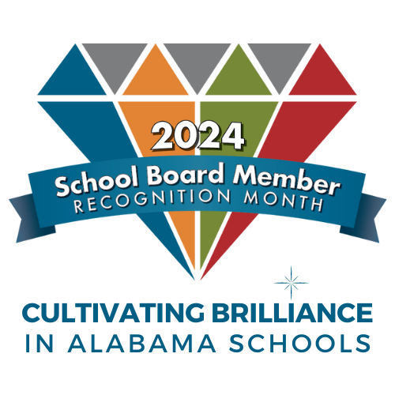
Honoring Our Local
School Board Members

School board members are responsible for making difficult decisions that impact students, parents, teachers, and the community every day. They work tirelessly to ensure that schools have the necessary resources to provide a safe and enriching learning environment for students. It’s important that we recognize their dedication and service to education, which is why we are taking the opportunity to show them our appreciation during School Board Member Recognition Month.

As elected officials school board members play a crucial role in shaping our children's education. Their decisions regarding curriculum, teachers, and school facilities can have a significant impact on the quality of education. They dedicate countless hours attending long meetings and conferences to develop policies that guide our public schools. As representatives of the community, they take their responsibility seriously, ensuring that the needs and concerns of the community are heard and addressed.

School board members are citizens whose decisions affect our children — what they learn, who will teach them and what kinds of facilities house their classrooms. These are men and women elected to establish the policies that provide the framework for our public schools. They represent you, and they take this responsibility seriously by attending lengthy — sometimes challenging — meetings and conferences.

Our school board is one of more than 130 such boards across the state. These boards enable us to have local control of public schools, meaning that decisions on school programming are made by local, elected representatives who understand the community’s unique problems, values, culture and circumstances. With the advice and counsel of the educational professionals they hire, our school board has an impact on virtually every aspect of our schools. It’s a huge responsibility and one that should not be taken lightly.

Too often we neglect to recognize the dedication and hard work of these men and women who represent us. The staff and students of our school district are asking all local citizens to take a moment to tell a school board member “thanks for caring about our children’s education.”

So, thank you to the dedicated men and women who make it possible for local citizens to have a say about education in our communities. We salute the public servants of (SCHOOL SYSTEM) whose dedication and civic responsibility make local control of public schools in our community possible. We applaud them for their vision and voice to help shape a better tomorrow.

