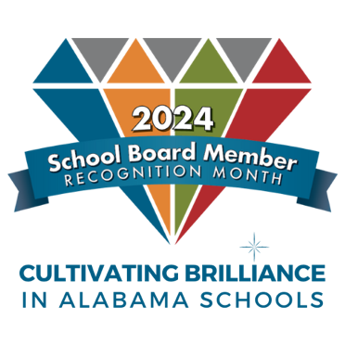
News Release

School Board Member
Recognition Month

To be typed on school system letterhead and mailed to local media outlets.

FOR RELEASE JANUARY 2024 For more information contact:
(Person’s name) (Phone number)
JANUARY IS SCHOOL BOARD MEMBER RECOGNITION MONTH

(City, Alabama) January is School Board Recognition Month and (school system’s name) is celebrating its board members for their dedication and commitment to the school system and its students.

The theme of this year’s School Board Recognition Month is Cultivating Brilliance in Alabama Schools, which aims to highlight the role board members play in fostering excellence in education throughout the state.

(School system’s name) is proud to honor and celebrate the exceptional dedication and unwavering commitment of its esteemed board members. These individuals play a vital role in shaping the future of education in our community, ensuring that every student receives the best possible opportunities for success.

“Our school board members are true champions of education, tirelessly working behind the scenes to make critical decisions that impact the lives of students, teachers, and families,” said (Superintendent name). “Their selfless service and unwavering commitment to the betterment of our school system deserve recognition and appreciation during School Board Member Recognition Month and beyond.”

(Summarize major district achievements and honors accomplished recently under the board’s leadership. Add details about specific activities planned in January for recognition month.)

Board members serving (school system name) are: (List their name and number of years on the board.)

During School Board Recognition Month, (school system’s name) encourages students, parents, teachers, and community members to join in expressing their appreciation for the board members' exceptional service. Whether through a simple thank-you note, a social media shout-out, or participation in the organized events, every gesture of gratitude will go a long way in acknowledging the board members' significant impact on our school system.

Learn more about school board service at AlabamaSchoolBoards.org.
# # #

