Sample
Letter
to
Employers
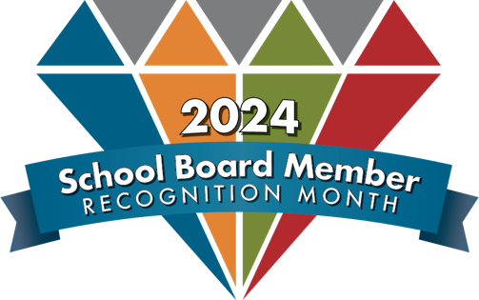

School Board Member Recognition Month
To be mailed by the superintendent or Chamber of Commerce

Dear:
I wanted to take a moment to express my sincere appreciation for allowing __________________________ time to serve as a member of the _________________________ Board of Education and ensure quality education for students in our community.
I have witnessed firsthand the dedication and commitment that they bring to board membership and public education. ____________________________ and other board members work tirelessly to improve educational opportunities for our students, and their efforts have not gone unnoticed.
School Board Member Recognition Month is being celebrated throughout Alabama and the nation in January, but I know that works hard and plays an important role in the lives of our community’s children year-round.
Serving on the school board is not a light responsibility to add into one’s daily life, but I am grateful for ____________________ and other members who choose to do so. I am sure their leadership will continue to make a positive impact on the lives of countless students and community members.
Sincerely,
[Your Name]

